Computer Language Coding Concepts

System Interface in a Diagram
The concept of the system interface is explained in the article System Interface. The current article only explains its expression in a diagram.

When an object has several interfaces, each interface is drawn out as a triangle, contained by the object, that supports the interfaces:

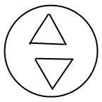

The complete notation for interfaces is explained in later articles. The system interface uses an alternative notation for an interface. The interfaces of an object are part of the target object, but the system interface is not part of the target object, but part of the object reference representing the target object. A symbol closely represents an object reference, rather than a specific object, therefore, the triangle that is to represent the system interface is stuck to the border of the symbol:

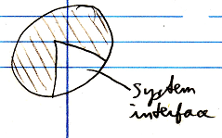

That way the interface is more part of the symbol, than part of the object.

To make more room inside the system interface, sometimes the following an exaggerated notation is used:

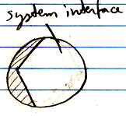

Normally, the system interface is not shown. Normally, the contents of the target object are shown inside the symbol.

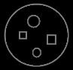

Showing the system interface is like breaking open the object reference to see its internal workings to adapt its configuration.

When the system interface is shown, the contents of the target object may not be shown inside the symbol anymore.

A system interface is the new computer language’s equivalent of Getters, Setters and Property procedures.

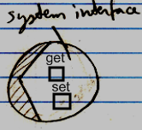

As such, all members of the system interface will all be displayed inside this triangle, stuck to the border of an object symbol.

A square is a symbol for a command. You will see command symbols in the system interface, even though the topic of commands has not been covered yet. Commands will be further explained in the Command articles.

See also: System Interface

Author & Copyright: Jan-Joost van Zon Date: July 18, 2008 – July 18, 2008 Location: Oosterhout, The Netherlands Status: Finished

